Experiment No: 3

Aim: Interfacing with Arduino uno - Buzzer, potentiometer, LED, Switch, Resistors

Objective:

1. Alternately turn ON / OFF the BUZZER
2. void setup()
3. {
4. pinMode(13, OUTPUT);
5. Serial.begin(9600);
6. while (!Serial);
7. Serial.println("Input 1 to Turn LED on and 2 to off");
8. }
9. void loop() {
10. if (Serial.available())
11. {
12. int state = Serial.parseInt();
13. if (state == 1)
14. {
15. digitalWrite(13, HIGH);
16. Serial.println("Command completed LED turned ON");
17. }
18. if (state == 2)
19. {
20. digitalWrite(13, LOW);
21. Serial.println("Command completed LED turned OFF");
22. }
23. }
24. }

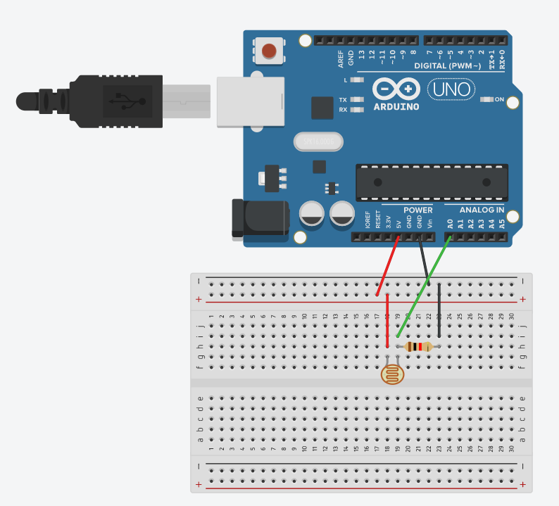

* Take input from LDR and print on serial monitor and control the external LED

const int ledPin=13;

const int ldrPin=A0;

void setup()

{

Serial.begin(9600);

pinMode(13,OUTPUT);

pinMode(A0,INPUT);

}

void loop()

{

int ldrstatus=analogRead(A0);

if(ldrstatus<=400)

{

digitalWrite(13,HIGH);

Serial.print("Turn on led: ");

Serial.println(ldrstatus);

}

else

{

digitalWrite(13,LOW);

Serial.print("Turn off led: ");

Serial.println(ldrstatus);

}

}

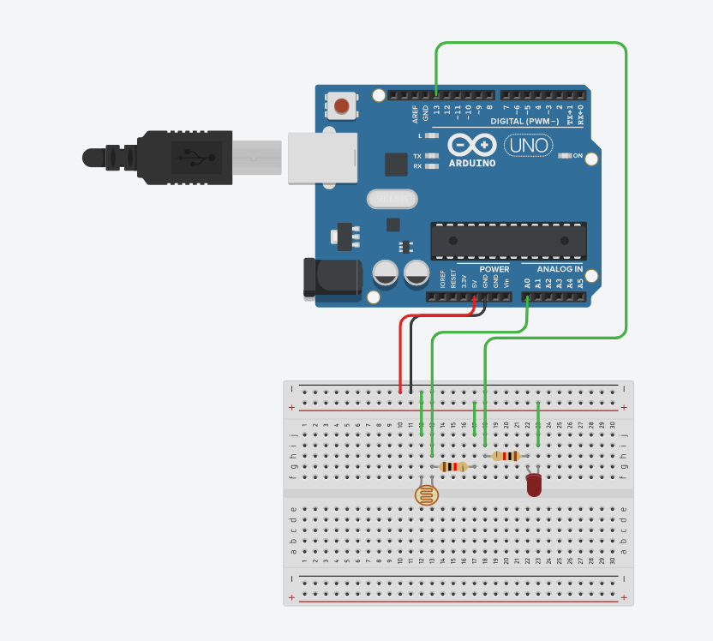

* Rotate servo motor by 45 or 90 degrees

#include <Servo.h>

Servo servo_1;

void setup()

{

servo_1.attach(2);

}

void loop()

{

servo_1.write(0);

delay(1000); // Wait for 1000 millisecond(s)

servo_1.write(45);

delay(1000); // Wait for 1000 millisecond(s)

}

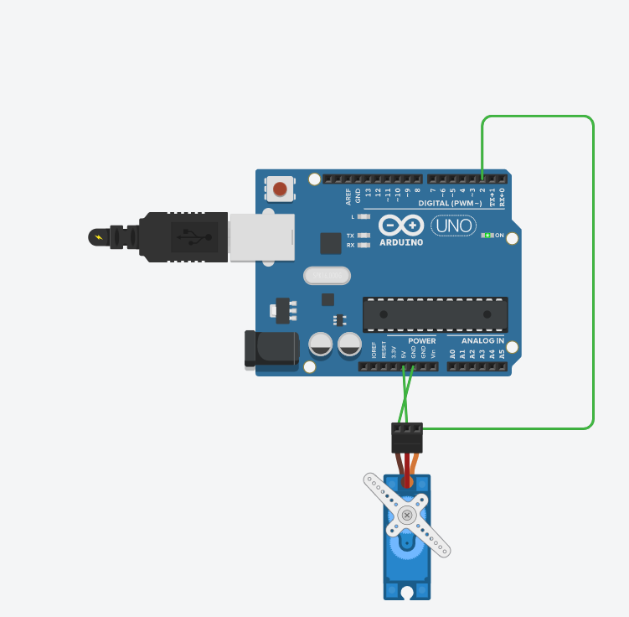

* If button is pressed servo will rotate 180 and return to 0

#include<Servo.h>

Servo my;

void setup()

{

pinMode(11,OUTPUT);

pinMode(2,INPUT);

my.attach(11);

}

void loop()

{

int buttonState=digitalRead(2);

if(buttonState==1)

{

my.write(180);

}

else

{

my.write(0);

}

}

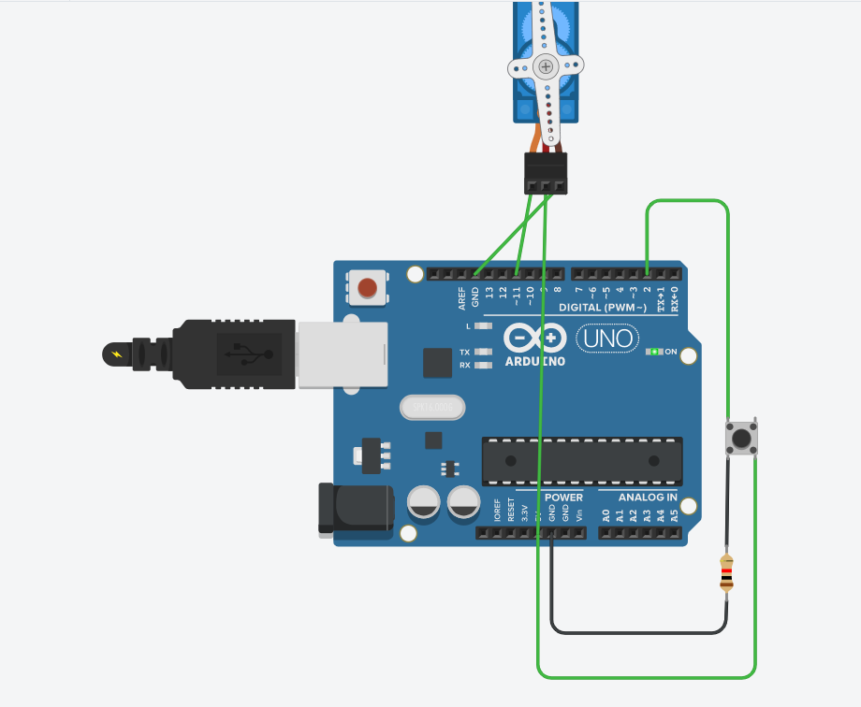

* Control servo shaft using potentiometer

#include<Servo.h>

Servo myservo;

int sensorValue=0;

void setup()

{

pinMode(A0,INPUT);

pinMode(12, OUTPUT);

myservo.attach(12);

}

void loop()

{

delay(100);

sensorValue=analogRead(A0);

myservo.write(map(sensorValue,0,1023,0,180));

delay(10);

}

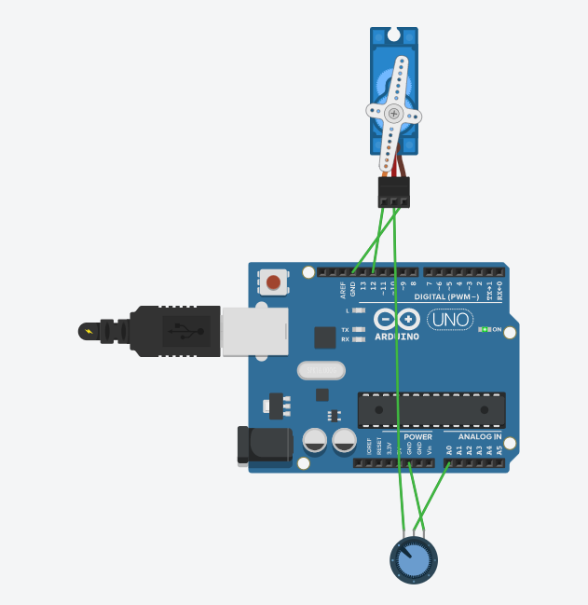

Rotate servo from 0 to 180 and back to 0,by changing shaft angle by 1 degree every 10ms

#include <Servo.h>

int pos = 0;

Servo servo_9;

void setup()

{

servo_9.attach(9, 500, 2500);

}

void loop()

{

for (pos = 0; pos <= 180; pos += 1) {

servo_9.write(pos);

delay(10); // Wait for 10 millisecond(s)

}

for (pos = 180; pos >= 0; pos -= 1) {

servo_9.write(pos);

delay(10); // Wait for 10 millisecond(s)

}

}

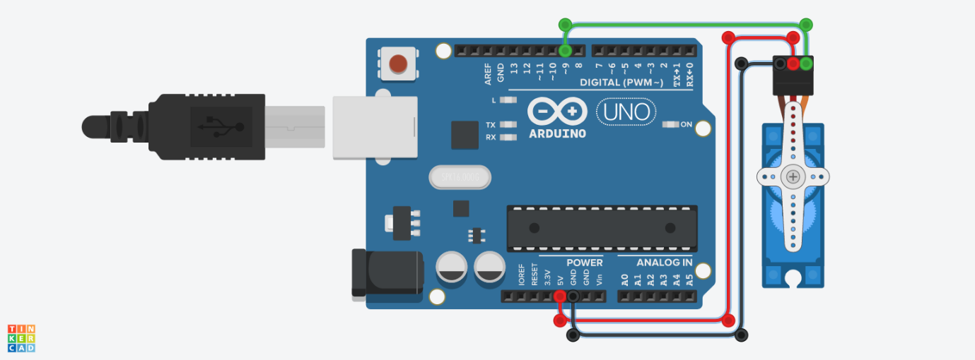

Open the door (rotate servo to 180 degree) when bell (buzzer) is heard on button press

#include<Servo.h>

int buttonState = 0;

Servo myservo;

int val;

void setup()

{

pinMode(2, INPUT);

pinMode(10, OUTPUT);

myservo.attach(8);

}

void loop()

{

int buttonState = digitalRead(2);

if (buttonState == HIGH) {

tone(10,250);

val=90;// door opening at 90 degree

delay(10);

noTone(10);

}

else {

val=0;

}

myservo.write(val);

delay(10);

}

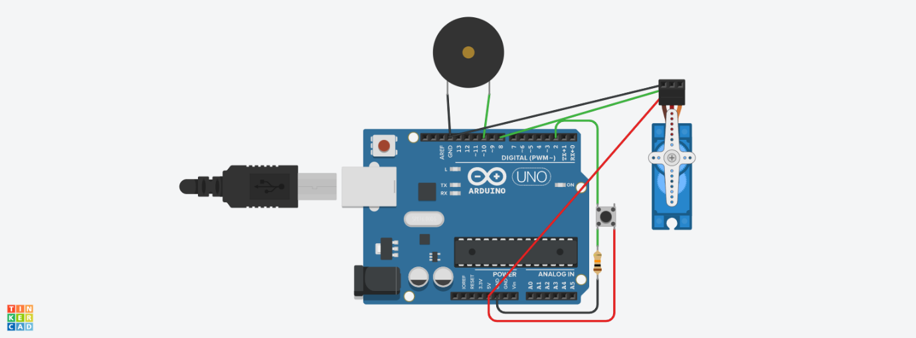

When traffic signal is red, door is closed (rotate servo by 0) and traffic signal is green, then door should open (rotate servo by 180)

#include<Servo.h>

Servo myservo;

void setup()

{

pinMode(6, OUTPUT);// green

pinMode(12, OUTPUT);// red

myservo.attach(2);

}

void loop()

{

digitalWrite(12, HIGH);

myservo.write(0);

delay(5000);

digitalWrite(12, LOW);

delay(500);

digitalWrite(6, HIGH);

myservo.write(90);

delay(5000);

digitalWrite(6, LOW);

delay(10);

}

